African Research Dissemination Workshop on Innovative Application of ICTs in Addressing Water-related Impacts of Climate Change, 12th December, 2014 Makerere University, Kampala Uganda
Workshop Theme
“Innovative Application of ICTs: bridging the gap between knowledge generation and end users for climate resilience building in Africa”
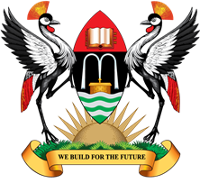    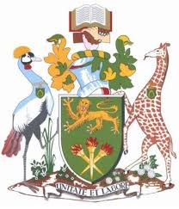  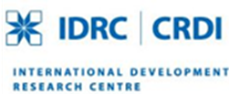  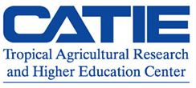  Background | Climate change is considered to be one of the most serious threats to sustainable development, with adverse impacts on all developmental sectors including agriculture. A significant body of evidence points to developing nations in Africa, Asia and Latin America as the most vulnerable regions to climate change. Most of the economies in these developing nations rely on rain-fed agriculture which supports between 70 and 80 per cent of employment and contributes an average of 30 per cent of gross domestic product (GDP) and at least 40 per cent of exports. Among many the vulnerabilities that are intensified by the effects of climate change, the availability and management of water resources constitute one of the most critical areas of concern for nations in Africa, Asia and Latin America. From the provision of basic services and sanitation, to irrigation and food production, ecosystems protection and hydropower generation, water resources are not only crucial for socio-economic development but also a fundamental dimension of climate change adaptation. Climate change is rapidly gaining currency as an area of intense research and many development partners are putting vast amounts of resources in this area. In Africa, Asia and Latin America, there is varied but limited research on the role of ICTs in dealing with the devastating effects of climate change. Further, universities in these regions do not have a coordinated mechanism to carry out research in ICT and climate change, which requires the collaboration of experts from various disciplines. Therefore in order to escalate the human resource capacity of scientists in ICTs in Africa, Asia and Latin America, Prof. Timothy Mwololo Waema and Dr. Laban MacOpiyo of the University of Nairobi in 2011 submitted a proposal to IDRC for a research grant on Innovative Application of ICTs in Addressing Water-related Impacts of Climate Change. This proposal was funded and a total of 31 grantees were recruited at MSc and PhD levels from Africa. The grantees have been conducting their scientific studies for a period of close to two years and have made a number of innovative headways. The spirit and zeal of these grantees from the Africa region now brings us to Kampala, Uganda to share their innovations, experiences and lessons in the use of ICTs in enhancing adaptation and resilience building to climate change in Africa. The workshop is slated for the 12th December, 2014 at Makerere University (CEDAT conference hall), Kampala Uganda from 8:30am - 4:30pm.
Aims & Objectives | The 1st Africa Research Dissemination workshop on Innovative Application of ICTs in Addressing Water-related Impacts of Climate Change will emphasize the use ICTs to a bridge between applications, information and knowledge generators and end users to enhance adaptation and resilience building to climate change in Africa. This one days’ workshop will specifically seek to:  - Provide the grantees with a platform to share research innovations, experiences and lessons in the development, use and dissemination of ICTs in tackling water resources challenges induced by climate change  - Bring stakeholders (end users, policy) to strengthen the synthesis of the emerging information from the implemented projects, deriving generic lessons, and to elicit input on the guidelines and procedures for optimizing the role of in adaptation and building resilience to climate change.
Workshop outputs | The workshop will generate the following outputs  - Regional common perspective on the role of ICTs in adaptation and resilience building to climate change with a focus to management of water resources  - Validation of information gathered from the various studies undertaken by the grantees over the last two year period  - A communiqué leading to a policy brief synthesizing the milestones of ICTs development and innovations that have the potential in the last mile communication with a potential to bridge developers and end user divide.
Approach and Methodology | The workshop will be characterised by invited keynote speeches, grantees oral presentations, panel discussions and poster presentations. In addition, there will be a consultative participatory session involving brainstorming, actor mapping and validation process.
Venue and Participants | The workshop will be held at Makerere University, Kampala Uganda on the 12th Decemeber, 2014 in the College of Engineering, Design, Art and Technology Conference Hall
Organisation and contacts | This workshop is organized by Makerere University in Collaboration with University of Nairobi. The Chief host is Dr. Bernard Barasa, Manager, GIS Centre. Email: barasa@cedat.mak.ac.ug, Tel: +256712712525 Other relevant contacts include: Mr. Egeru Anthony; Department of Environmental Management. Email: egeru81@mail.com, Tel: +256759744900

